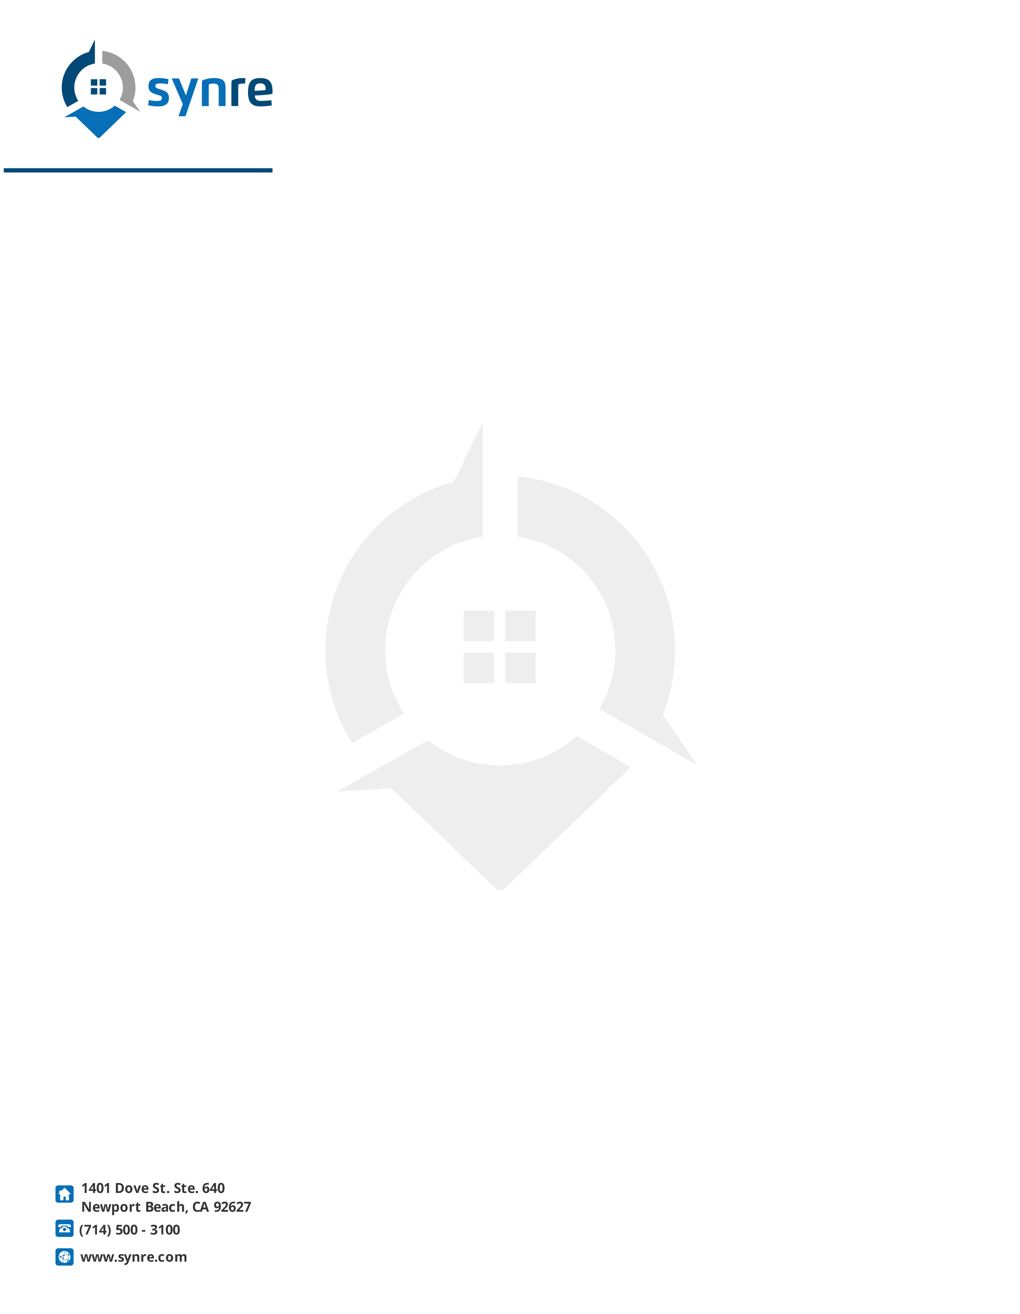
HERE’S YOUR MLS COPY

Date

Name
Address
City, ST Zip

Name:

Here is a copy of your property as it appears on the MLS printout for the entire (board of Realtors®), Realtor.com, and other Internet platforms such as Pinterest, Vimeo, Twitter, Facebook, and more. Also, this is the same information provided in our agent networking programs and in our buyer’s assistance program.

When the agents/brokers come to view your property, please let us know so that I can follow-up with them. You will find self-addressed return envelopes for this purpose enclosed or you can log in the information at SynRE.com.

In the meantime, I will continue to aggressively market your property! If you have any questions, please contact my staff or me. We are always happy to assist you. As we make updates on any marketing information for your property, you can view them at your exclusive page at SynRe.com.

Sincerely,

(Name here)
Synergy Real Estate

